Bio C Svampecellers opbygning (her: gær, en encellet svamp)

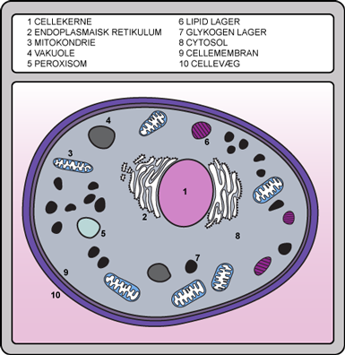
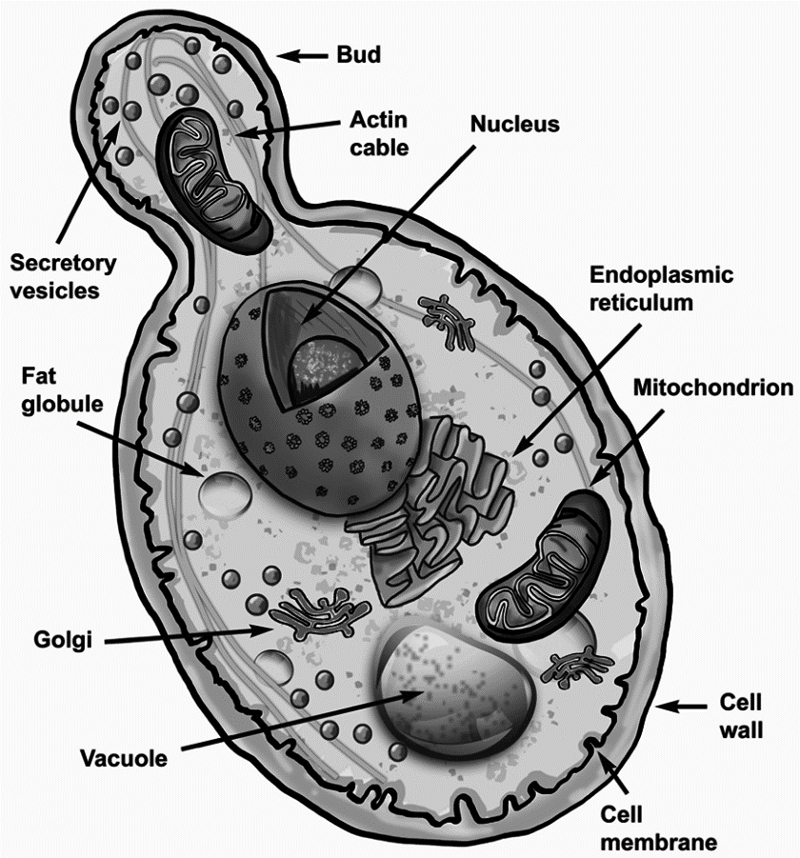

Bio C Svampecellers opbygning (her: en flercellet svamp)

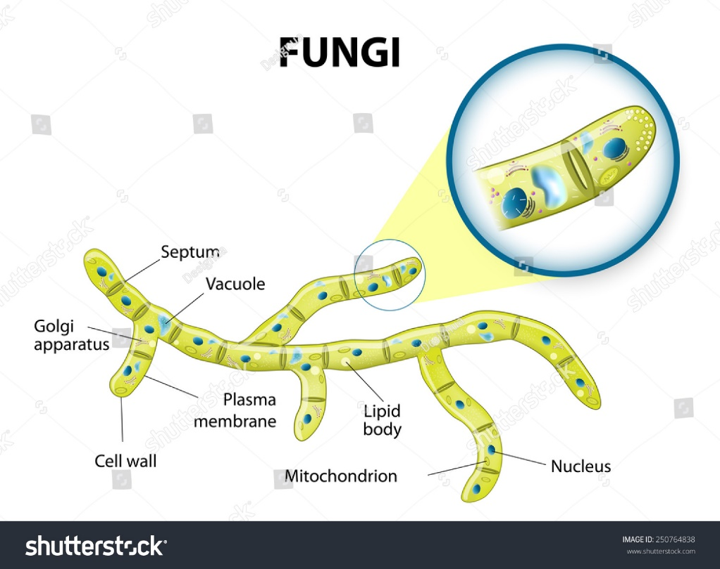
Typical fungi cell. Fungal Hyphae. Structure fungi. Diagram illustrating the ultrastructure of a septate hypha.

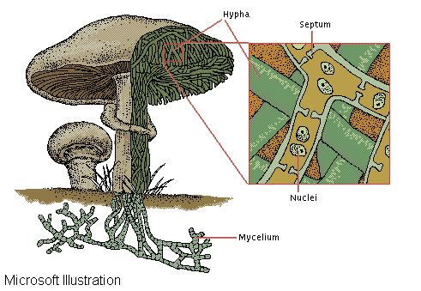
Fungi are made of filamentous tubes called hyphae. In many species, perforated walls, or septa, divide the hyphae into cells containing one or two nuclei.

